version 1

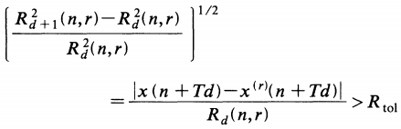





 is embedding dimension

 is time delay

is some threshold, then the neighbours are said to be false.

 is an estimate of the attractor size

is the second threshold.

Kennel et al. recommend the next settings of the thresholds: , 

version 2

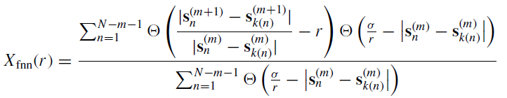

false nearest neighbors

参数：

series time series

m maximum embedding dimension

The percentage of false nearest neighbours will be computed from embedding dimension 1 up to this maximum embedding dimension

**d delay parameter**

The time delay is set as the first minimum of **the mutual information function.** The mutual information acts as the equivalent of the correlation function in a nonlinear domain. (nonlinear correlation)

t Theiler window

rt escape factor

distance tolerance rt - This is a threshold for the embedding criterion (see above). The choice of rt  10 will usually identify the FNN clearly. Very high values of rt will result in an underestimation of the number of FNN. Very low values for rt will identify too many false nearest neighbours, in particular when the points on the attractor become sparse

eps neighborhood diameter

sd(series)/rt

*Kennel’s Algorithm.*

<http://www.mpipks-dresden.mpg.de/~tisean/TISEAN_2.1/docs/chaospaper/node9.html>

<http://help.ixellence.com/dataplore/dp_manual90.html>

*Cao’s Algorithm.*

<http://www.physik3.gwdg.de/tstool/HTML/node15.html>

Reference:

**Determining embedding dimension for phase-space reconstruction using a geometrical construction**

**Use of False Nearest Neighbours for Selecting Variables and Embedding Parameters for State Space Reconstruction-krako2015**

**Time Series Prediction and Neural Networks-neural30-notes**

**Holger Kantz, Thomas Schreiber,-Nonlinear Time Series Analysis, 2nd Edition (2004)**

Modelling and Forecasting Financial Data_ Techniques of Nonlinear Dynamics-Abdol S. Soofi, Liangyue Cao-Springer